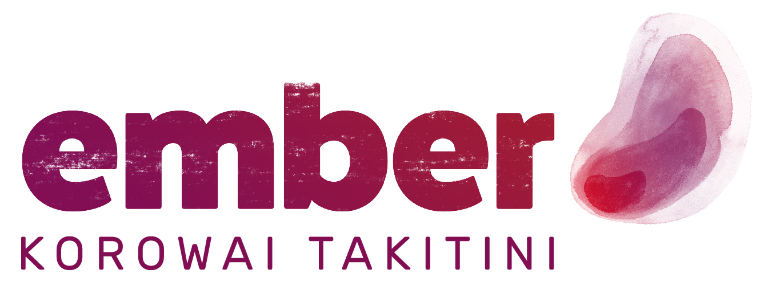

JOB DESCRIPTION

Position: Senior Support Worker - Awake  Date prepared: 29/09/2021  Date reviewed: | Prepared by: W.V, K.M, L.B

PRIMARY OBJECTIVES:
The Senior support worker leads the awake shift to ensure that staff and client needs are meet whilst providing consistent and high-quality support during the hours of 11pm – 7am.

Provides cover of annual/sick or unplanned leave of the awake over role

Reports to: | Team Manager
Key Relationships: | Internal | External
Key Relationships: | - General Manager  - Team Manager  - Support Workers  - Registered Health Professional and Nurses | - Family/Whanau and significant others  - Community Mental Health (Acute Crisis Team)
Role Accountabilities
Deliverables/outcomes | - Leadership  - Monitoring of the shift and service  - Support training and development of team members  - Ensure that awake staff are working to their relevant job description  - Undertakes the relevant job tasks when covering awake shifts  - Provides coaching and support
Client responsibilities | - Ensure staff understand client needs and deliver the expected outcomes  - Regularly review risk management plan and documentation
Operational management | - Work with the staff to support the organisation’s strategic plan  - Monitor and report on progress of client plans and staff performance  - Foster a client focused working environment, with clear responsibilities and expectations for awake staff members.
Relationship management | - Ensure staff members understand client needs and deliver on support plans  - Regularly review work processes for areas of improvement.  - Ensure staff are informed of and trained in safe practices and procedures in their specific areas of work.  - Adhere to all Ember policies.

The above statements are intended to describe the general nature and level of work being performed. They are not intended to be a complete list of all responsibilities, duties and skills required of the position and the job holder.

KEY COMPETENCIES/SKILLS

Skills:

Personal Attributes:

Role-models and upholds key EMBER Values:

- Whakapono – We demonstrate belief and passion in everything we do. The love we demonstrate for our work and our faith in its outcomes drives us to be the best we can be.

- Tino rangatiratanga – We put people first. We believe that all people have the right to self-determination. We create opportunities that allow people to achieve their potential and restore their tapu and mana.

- Kotahitanga – We work as a team and we work in teams. We always strive to create partnerships and to maintain togetherness in all our endeavours.

- Kia Pono, Kia Tika – We recognise that our work is not easy. We combine professional and lived experience to stay grounded. We keep it real; we keep it honest, and we always behave with integrity.

I have read and understood my job description including the attached Appendix A: Hazard/Risk Register and Controls:

Name: _______________________________ Signature: ____________________________

Date: ______________________

APPENDIX A
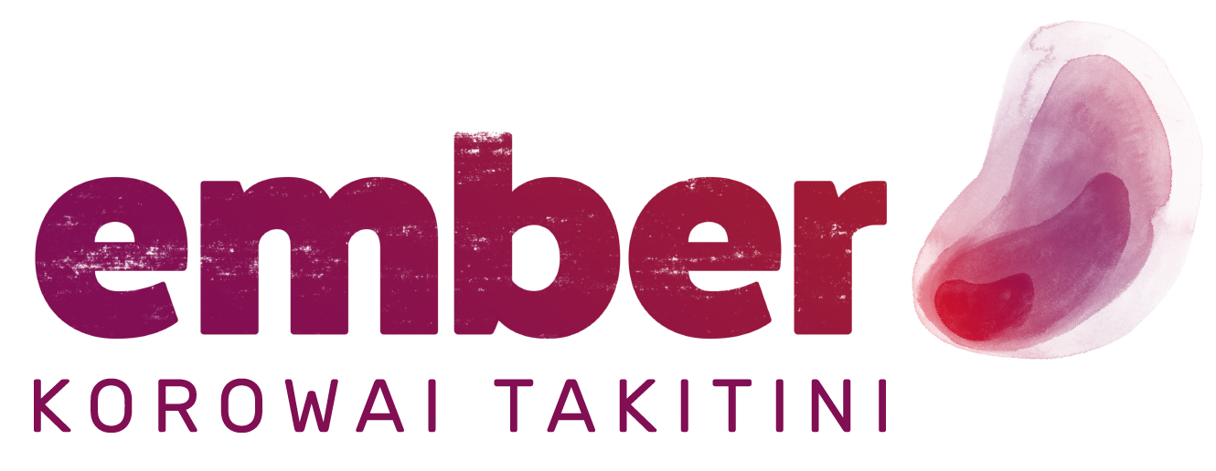 | hazard/risk register and controls

All work roles have inherent hazards associated with them. The roles that you will be involved in at Ember are no exception. As your employer, Ember is required by law to manage such hazards and the associated risks.

Possible hazards associated with your role are detailed in this document, together with measures that have been designed to ensure your Health, Safety and Wellbeing (H&S)

The listed ‘control’ measures include various equipment, processes, policies and/or approved procedures.

All employees are expected and required to follow the established controls.

In addition to the above, all work areas have processes in place to identify hazards specific to that area. Your site H&S representative/s are trained and will be able to assist you with any H&S issue.

Risk / Hazard Identification |  |  | Risk | Risk Control
Role/Task/Position | Hazard / Potential Risk | Risk/hazard may present itself: | Level of Risk | Risk controls in order of preference | Residual Risk
VDU users  (all employees) | Strain / Injury | Overuse and/or  ergonomics | Low | Minimize by:  Workstation assessment, equipment and setup  VDU Training  Manually varying tasks  Taking regular breaks away from computer or task  Annual review of workstation setup. | Very Low
Manual handling/lifting | Strain | Excess weight | Low | Minimize by:  Back Care training  Utilizing appropriate services  Use of trolleys  Ask others for help/assistance | Very Low
Working with public and clients | Stress | Verbal Abuse, Violence/aggression | Medium to High | Minimize by:  Attend appropriate training  Utilize team-based processes  Supervision  Debriefs  Be familiar with procedures for dealing with violence (security, police) | Medium
Working with public and clients  (all support workers) | Infectious Disease  Pandemics | Unwell (infectious people) | High | Minimize by:  Infection control training appropriate to area – local procedures  Utilizing Personal Protective Equipment (PPE)  Paid sick leave and Return to Work programme  Vaccination programmes  Lockdown protocols  Self- Isolation  Contact tracing  Maintaining personal hygiene  Regular hand washing  Social distancing  Ember / Government / Ministry Pandemic plan and guidelines | High

Role/Task/Position | Hazard | Possible Outcome | Controls in place to Manage
Working with public in the community | Isolation/lack of support | Poor outcomes, stress, potential injury | Minimize by:  Safety in the Community Policy – alert to danger cards  Local procedures (e.g., cell phones, access to consultation)  Team based reviews, risk management plans  Employee Assistance Programme (Benestar counselling/support)  Regular supervision with Manager  GPS tracking  Personal alarms  Diary Management  In & Out boards on site  Phone in to Team Manager at the end of the day  On-call management outside of normal 9-5 working hours
Driving for work – company vehicles  (All Employees) | Usual traffic hazards | Breakdown/injury | Eliminate/Minimize by:  Current driver’s license/NZTA Driver Check  Vehicle maintenance/e-learning training  Plan journeys and allow time for travel  Driver responsibility  Insurance/roadside rescue  Observing the speed limits  GPS speed monitoring and tracking
All Employees | Slip, trips and falls | Potential Injury | Eliminate/Minimize by:  All employees are required to clean up a spill or remove an unsafe obstacle  Report hazard to Manager or H&S Rep  Use of provided ‘Spill Kit’  Isolate any hazard/obstacle

Role/Task/Position | Hazard | Possible Outcome | Controls in place to Manage
All Employees | Long hours  Lack of training/support  Bullying  Harassment | Stress | Minimize by:  Report hazards, alert Line Manager, attend regular supervision  Regular meetings and appropriate training  Employee Assistance Programme (Benestar counselling/support)  Utilising own GP  Harassment Policy/Officers  Having regular leave for rest and relaxation.
All Employees | Machinery/electrical appliances | Potential Injury  Lack of service | Minimize by:  Regular maintenance / checklist  Utilizing appropriate support services  Report hazard to Manager or H&S Rep
All Employees | Chemicals (very limited) | Exposure/Injury | Minimize and/or Eliminate by:  Clearly labelled and correctly stored  Accompanying Safety Data Sheet (S.D.S) / manufacturer’s instructions  Training  Purchase and use of non-toxic cleaning materials
UV Exposure (All involved in outdoor activities) | Sunburn  Sun Stroke | Skin damage  Skin cancer | Eliminate by:  Use of Sunscreen, hats & suitable clothing  Shaded areas / Sun Smart policy  Training, information and guidance

