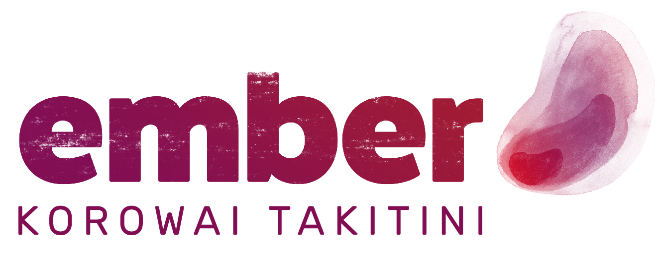

JOB DESCRIPTION

Position: Support Worker  Date prepared:  Date reviewed: June 2022 | Prepared by: W.V, L.B, R.B

PRIMARY OBJECTIVES:
The delivery of support for clients/tangata whai ora residing in the service, offering direct intentional support and therapeutic intervention. Team Members will be expected to practice within Ember’s holistic rehabilitation model, utilising their professional skills, knowledge, and experience.

Reports to: | Team Manager
Key Relationships: | Internal | External
Key Relationships: | - Team Manager  - Team Members  - Other Ember employees  - Clients/Residents/Tangata Whai Ora | - Community Services/Organisations  - Local Mental Health Services  - Family/Whanau  - Other clinical services

Key Results Areas | Key Tasks | Expected Outcomes/Measures
Ensures that all clients are receiving a service that is tailored to their needs and aspirations addressing psychological, physical, spiritual, and family/whanau issues via individual client pathways | - Knowledge based approaches are being utilized that address all aspects of health and wellbeing.  - Relationships are developed with community resources. Clients are provided with information and resources in order that they can make informed choice about their future. | - Clients are recovering.  - Documentation demonstrates that all aspects of wellbeing and wellness are being explored.  - Client and family/whanau surveys indicate high levels of satisfaction
Liaises with clinical teams | - Communicates regularly and effectively and works collaboratively with members of the clinical teams, both reactively in relation to supporting individual clients and pro-actively through building relationships | - Ember will be recognized as being professional and collaborative through the clinical service feedback in the service audit

Adheres to client management systems including medication management, blood testing, reviews, and reports. Works within the organizations policies and procedures | - Works within and contributes to the development of effective systems for ensuring that clients/tangata whai ora receive support and treatment as scheduled, including.  - Medication Management  - Blood testing  - Regular physical checks  - Monitoring diarising of support  - Monitoring of reviews  - Monitoring production and communication of reports  - Is conversant with all policies and procedures. | - Review of documentation will demonstrate that clients have received support and treatment as planned
Provides direct support to clients and their family/whanau on an individual and group basis to find, get and keep accommodation, work, valued roles, and relationships of choice or build readiness to do this | - Demonstrates competence in rehabilitation approaches including.  - Connecting  - Assessments  - Skills  - resources building  - rehabilitation readiness development and evaluation. | - Clients are recovering  - Clients are building rehab readiness  - Clients are setting, working towards, and achieving goals  - Clients are moving out of the service into accommodation of choice with the paid and natural support that they require.  - Clients are working, learning, and socializing in the community
Participating actively in the Residential Team | - Works supportively and effectively with other team members to achieve the goals of the team | - 360° feedback indicates that the post holder is an active team member and role models and demonstrates the vision, mission and values of the organisation
Engaging in professional supervision, training, and development | - Participates in performance reviews and establishes and carries out professional development plan  - Participates in line-management fortnightly supervision  - Participates in professional or external supervision | - Performance review will demonstrate that the post holder is developing professionally and improving skills and attributes
Practices effective self-care | - Balances demands of non-work and work life  - Seeks support and help when needed  - Prioritises and completes work  - Conducts self in an energetic and positive manner | - 360° feedback indicates that the post holder is perceived as professional, positive and manages workload and life balance effectively.

The above statements are intended to describe the general nature and level of work being performed. They are not intended to be a complete list of all responsibilities, duties and skills required of the position and the job holder.

KEY COMPETENCIES/SKILLS
Skills:
- Working with people and Whanau with mental health and addiction needs
- Working with Māori
- Working with Families/Whanau
- Working within Communities
- Challenging Stigma and Discrimination
- Upholding Law, Policy and Practice
- Maintaining Professional and Personal Development

Personal Attribute:
- Lived experience of recovery from mental health issues and/or addictions
- Compassionate & Caring: sensitive and empathetic
- Genuine: warm, friendly, fun, have aroha and a sense of humour
- Non-judgmental: non-discriminatory, welcomes diversity
- Open-minded: culturally aware, self-aware, innovative, creative, and positive risk takers
- Optimistic: positive, encouraging, and enthusiastic
- Patient: tolerant and flexible
- Professional: accountable, reliable, and responsible
- Resilient
- Supportive: validating, empowering, and accepting
- Understanding

Role-models and upholds key Ember Values:
- Whakapono – We demonstrate belief and passion in everything we do. The love we demonstrate for our work and our faith in its outcomes drives us to be the best we can be.
- Tino rangatiratanga – We put people first. We believe that all people have the right to self-determination. We create opportunities that allow people to achieve their potential and restore their tapu and mana.
- Kotahitanga – We work as a team, and we work in teams. We always strive to create partnerships and to maintain togetherness in all our endeavours.
- Kia Pono, Kia Tika – We recognise that our work is not easy. We combine professional and lived experience to stay grounded. We keep it real; we keep it honest, and we always behave with integrity.

I have read and understood my job description including the attached Appendix A: Hazard/Risk Register and Controls:

Name: _______________________________ Signature: ____________________________

Date: ______________________

APPENDIX A
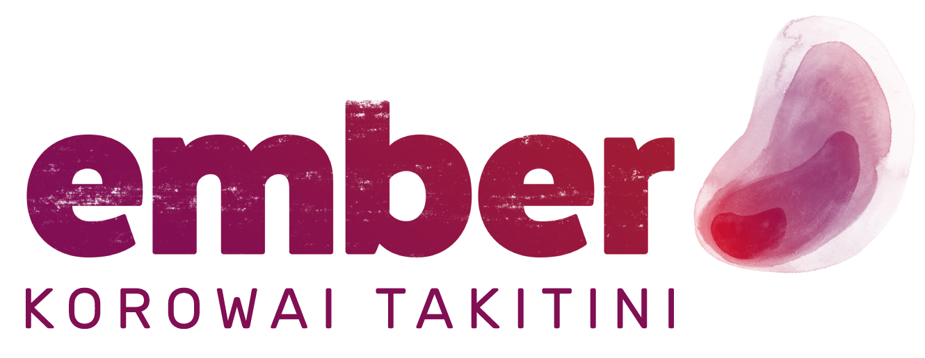 | hazard/risk register and controls

All work roles have inherent hazards associated with them. The roles that you will be involved in at Ember are no exception. As your employer, Ember is required by law to manage such hazards and the associated risks.

Possible hazards associated with your role are detailed in this document, together with measures that have been designed to ensure your Health, Safety and Wellbeing (H&S)

The listed ‘control’ measures include various equipment, processes, policies and/or approved procedures.

All employees are expected and required to follow the established controls.

In addition to the above, all work areas have processes in place to identify hazards specific to that area. Your site H&S representative/s are trained and will be able to assist you with any H&S issue.

Risk / Hazard Identification |  |  | Risk | Risk Control
Role/Task/Position | Hazard / Potential Risk | Risk/hazard may present itself: | Level of Risk | Risk controls in order of preference | Residual Risk
VDU users  (all employees) | Strain / Injury | Overuse and/or  ergonomics | Low | Minimize by:  Workstation assessment, equipment and setup  VDU Training  Manually varying tasks  Taking regular breaks away from computer or task  Annual review of workstation setup. | Very Low
Manual handling/lifting | Strain | Excess weight | Low | Minimize by:  Back Care training  Utilizing appropriate services  Use of trolleys  Ask others for help/assistance | Very Low
Working with public and clients | Stress | Verbal Abuse, Violence/aggression | Medium to High | Minimize by:  Attend appropriate training  Utilize team-based processes  Supervision  Debriefs  Be familiar with procedures for dealing with violence (security, police) | Medium
Working with public and clients  (all support workers) | Infectious Disease  Pandemics | Unwell (infectious people) | High | Minimize by:  Infection control training appropriate to area – local procedures  Utilizing Personal Protective Equipment (PPE)  Paid sick leave and Return to Work programme  Vaccination programmes  Lockdown protocols  Self- Isolation  Contact tracing  Maintaining personal hygiene  Regular hand washing  Social distancing  Ember / Government / Ministry Pandemic plan and guidelines | High

Role/Task/Position | Hazard | Possible Outcome | Controls in place to Manage
Working with public in the community | Isolation/lack of support | Poor outcomes, stress, potential injury | Minimize by:  Safety in the Community Policy – alert to danger cards  Local procedures (e.g., cell phones, access to consultation)  Team based reviews, risk management plans  Employee Assistance Programme (Benestar counselling/support)  Regular supervision with Manager  GPS tracking  Personal alarms  Diary Management  In & Out boards on site  Phone in to Team Manager at the end of the day  On-call management outside of normal 9-5 working hours
Driving for work – company vehicles  (All Employees) | Usual traffic hazards | Breakdown/injury | Eliminate/Minimize by:  Current driver’s license/NZTA Driver Check  Vehicle maintenance/e-learning training  Plan journeys and allow time for travel  Driver responsibility  Insurance/roadside rescue  Observing the speed limits  GPS speed monitoring and tracking
All Employees | Slip, trips and falls | Potential Injury | Eliminate/Minimize by:  All employees are required to clean up a spill or remove an unsafe obstacle  Report hazard to Manager or H&S Rep  Use of provided ‘Spill Kit’  Isolate any hazard/obstacle

Role/Task/Position | Hazard | Possible Outcome | Controls in place to Manage
All Employees | Long hours  Lack of training/support  Bullying  Harassment | Stress | Minimize by:  Report hazards, alert Line Manager, attend regular supervision  Regular meetings and appropriate training  Employee Assistance Programme (Benestar counselling/support)  Utilising own GP  Harassment Policy/Officers  Having regular leave for rest and relaxation.
All Employees | Machinery/electrical appliances | Potential Injury  Lack of service | Minimize by:  Regular maintenance / checklist  Utilizing appropriate support services  Report hazard to Manager or H&S Rep
All Employees | Chemicals (very limited) | Exposure/Injury | Minimize and/or Eliminate by:  Clearly labelled and correctly stored  Accompanying Safety Data Sheet (S.D.S) / manufacturer’s instructions  Training  Purchase and use of non-toxic cleaning materials
UV Exposure (All involved in outdoor activities) | Sunburn  Sun Stroke | Skin damage  Skin cancer | Eliminate by:  Use of Sunscreen, hats & suitable clothing  Shaded areas / Sun Smart policy  Training, information and guidance

